**LeCroy 3377 TDC Data Acquisition via LeCroy 8901 GPIB->CAMAC Controller Manual**

### Please note this code has been developed specifically for the LeCroy 8901 GPIB->CAMAC controller, the LeCroy 8901A device may behave differently.

# Usage

TDC3377DAQ.exe [CONFIG FILENAME]

e.g.

TDC3377DAQ.exe ComStop.cfg

# Configuration File Syntax

The commands below will setup the TDC for data acquisition, comments are preceded by //

**BASE_PATH**

Base path for files e.g. C:/Data/ will save files in C:\Data\YYYY\ReMiDDMMHHMM-Target\ **use forward slashes**

**GAS_TARGET**

Descriptor for the run target e.g. Argon which is saved to the metafile

**GAS_PRESSURE**

Descriptor for gas pressure e.g. 1e-5torr which is saved to the metafile

**ENERGY**

Descriptor for incident beam energy e.g. 19eV which is saved to the metafile

**MAGNETIC_FIELD**

Descriptor for magnetic field strength e.g. 10Gauss which is saved to the metafile

**GPIB_ADDRESS**

Address of the GPIB controller e.g. 3

**TDC_SLOT**

Slot in the CAMAC where the TDC is installed e.g. 9

**DWV_SLOT**

Slot in the Camac where the Dataway Visualiser is installed e.g. 2

**TDC_MODE**

Control Register 0 - bit 14, 15 (Read only) : indicates the program load in use.

0 = Common Stop Single Word

1 = Common Start Single Word

2 = Common Stop Double Word

3 = Common Start Double Word

**MODULE_ID**

Control Register 0 - bits 0-7: user definable module ID code. This appears in the header data word. Default is 0.

**TDC_RESOLUTION**

Control Register 0 - bits 8-9: data shift value. This determines the TDC resolution.

0 = 0.5 nsec (default)

1 = 1.0 nsec

2 = 2.0 nsec

3 = 4.0 nsec

**EDGE**

Control Register 0 - bit 10: Selects LEADING edge recording, or BOTH edges.

1 = Both edges are recorded

0 = Leading edge ONLY is recorded (default)

**READOUT_MODE**

Control Register 0 - bit 11: Selects readout mode.

1 = ECL PORT (FERA mode)

0 = CAMAC readout (default)

**BUFFER_MODE**

Control Register 0 - bit 12: Selects Buffer mode

1 = Multi-event buffer mode

0 = Single buffer mode. In this mode the FERA

readout is compatible with the 4300B FERA ADC. The request delay (see register 3) must be set appropriately. (default)

**HEADER_MODE**

Control Register 0 - bit 13: Selects Header mode

0 = always have header (default)

1 = skip header if no data words

**TRIGGER_OP_PULSE_WIDTH**

Control Register 1 - bits 0-3: Selects the trigger output pulse width, in clock units, 0 to 15. Default is 0.

**TRIGGER_PULSE_DELAY**

Control Register 1 - bits 4-7: Selects the trigger pulse delay, in clock units. The maximum delay is 15 clock units. Default is 0.

**TRIGGER_CLOCK_UNIT**

Control Register 1 - bits 8-9: Selects the trigger clock unit.

0 = 25 nsec (default)

1 = 50 nsec

2 = 100 nsec

3 = selects external trigger clock

**MPI**

Control Register 1 - bit 10-11: Selects the Measure Pause Interval (MPI).

0 = no MPI (default)

1 = 800 nsec MPI

2 = 1600 nsec MPI

3 = 3200 nsec MPI

**FAST_FERA_MODE**

Control Register 1 - bit 12: Selects FAST FERA mode; 1=fast 0=normal (default)

**EVENT_SERIAL_NO**

Control Register 1 - bit 13 - 15: Event serial number. This 3 bit number is in the header data word. It is incremented after each event. It can be written and read to allow synchronizing several modules. It is cleared by CAMAC command F9. Default is 0.

**HITS_PER_CHANNEL**

Control Register 2 - bits 0-3: The maximum number of hits allowed per TDC channel, from 1 to 16. A value of zero selects 16 hits. Default is 15.

**MAXIMUM_FULL_SCALE_TIME**

Control Register 2 - bits 4-15: The maximum full scale time allowed for the TDC data, in units of 8 nsec, from 0 to 32767.5 nsec. Bit 4 has a value of 8 nsec.

**REQUEST_DELAY_SETTING**

Control Register 3 - bits 0-3: The request delay setting. This is used only in 4300B FERA ADC compatible mode. The range is from 0 to 30 microseconds, in 2 microsecond steps. In this mode the BUSY output becomes the FERA REQUEST output. Default is 0.

**COM_START_TO_VALUE**

Control Register 4 - bits 0-9: The Common start time out value in units of 50 nsec, up to 32 microseconds. The minimum delay is about25 nsec, for a setting of 0. The actual value jitters 50 nsec due to the synchronization with the internal 50 nsec clock. This MUST be set to a value LESS THAN full scale (32,767.5 microseconds).

**TEST_MODE**

Control Register 5 - bit 8 Test enable. This must be 1 for test mode.

**TEST_MODE_CLOCK**

Control Register 5 - bits 5-6: The test mode clock.

0 = 100 nsec

1 = 200 nsec

2 = 400 nsec

3 = 800 nsec

**NO_TEST_PULSES**

Control Register 5 - bits 0-4: The number of pulses generated in test mode. 0-31 pulses, each 1/2 clock period long.

# Example Configuration File

//Configuration as per default values in the previous Labview acquisition VI

//CR0: 1001000000000000

//CR1: 0000001011110000

//CR2: 1111101000000110

//CR3: 0000000000000000

//FILE LOCATION

//Use forward slashes

//files will be rootHHMMSS.root, rawHHMMSS.txt , and metaHHMMSS.txt

**BASE_PATH C:/data/**

//META DATA

**GAS_TARGET Argon**

**ENERGY 190eV**

**MAGNETIC_FIELD 10G**

**GAS_PRESSURE 1e-5**

//HARDWARE SETUP

**GPIB_ADDRESS 3**

**TDC_SLOT 9**

**DWV_SLOT 2**

//TDC MODE 2 = Common Stop

**TDC_MODE 2**

//CR0

**MODULE_ID 0**

**EDGE 0**

**READOUT_MODE 0**

**BUFFER_MODE 1**

**HEADER_MODE 0**

//CR1

**TRIGGER_OP_PULSE_WIDTH 0**

**TRIGGER_PULSE_DELAY 15**

**TRIGGER_CLOCK_UNIT 2**

**MPI 0**

**FAST_FERA_MODE 0**

**EVENT_SERIAL_NO 0**

//CR2

**HITS_PER_CHANNEL 6**

**MAXIMUM_FULL_SCALE_TIME 4000**

//CR3

**REQUEST_DELAY_SETTING 0**

# Output Files

Each time data acquisition is started, 3 output files are generated a raw file, a root file and a meta file. The Metafile called MetaHHMMSS.txt (where HH:MM:SS is the start time of the run) contains information about the run, including the target, magnetic field, gas pressure, and incident beam energy given in the configuration file. An example meta-file is included below:

**Date : 01-05-2016**

**Start Time : 10:00:00**

**Target : Argon**

**Magnetic Field : 10Gauss**

**Gas Pressure : 1e-5Torr**

**Incident Beam Energy : 190eV**

**TDC Control Registers**

**CR0 : 0001000000000000**

**CR1 : 0000001011110000**

**CR2 : 1111101000000110**

**CR3 : 0000000000000000**

**CR4 : 0000000000000000**

**CR5 : 0000000000000000**

**Stop Date : 02-05-2016**

**Stop Time : 10:05:00**

The raw file (rawHHMMSS.txt) contains all the unsigned 16 bit integer data words read in from the TDC saved as ASCII tab separated values. Each group of data is preceded by a header word which can be identified as described in the 3377 TDC manual.

**HEADER WORD**

**DATA WORD**

**DATA WORD**

**DATA WORD**

**DATA WORD**

**…**

**DATA WORD**

The root file (RootHHMMSS.root) contains a tree with 3 branches, group number, channel, and time. The group number begins at 0 and is increased by 1 each time a new header word is read from the TDC. The Channel is found by reading the appropriate bits from the data word and time is calculated from the double word format as described in the 3377 TDC manual. This file can be read directly using ROOT available from (<https://root.cern.ch/>).

# Editing the code

The code was written in C++ using Visual Studio 2015, this IDE is available for free from Microsoft (<https://www.visualstudio.com/>). This also requires the ROOT environment (<https://root.cern.ch/>) and National Instruments 488.2 GPIB driver available from (<http://www.ni.com/download/ni-488.2-14.0/4802/en/>).

Please note on 64 bit machines **C:\Program Files\** should be replaced with **C:\Program Files (x86)\**

**Includes Directories**

C:\root_vx.xx.xx\include

C:\Program Files\National Instruments\Shared\ExternalCompilerSupport\C\include

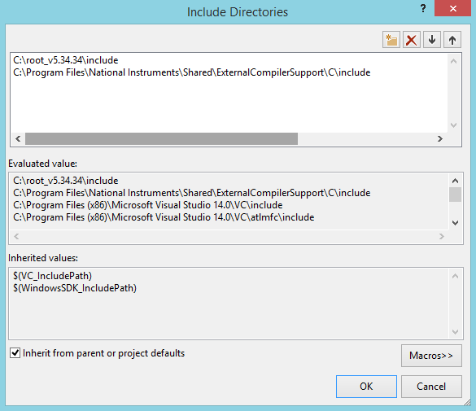

**Library Directories**

C:\root_vx.xx.xx\lib

C:\Program Files\National Instruments\Shared\ExternalCompilerSupport\C\lib32\msvc

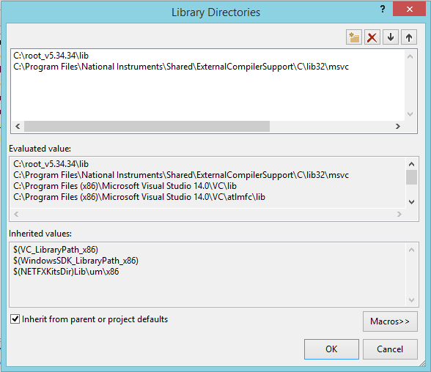

**Linker Additional Dependencies**

C:\Program Files\National Instruments\Shared\ExternalCompilerSupport\C\lib32\msvc\*.lib

C:\root_v5.34.34\lib\*.lib

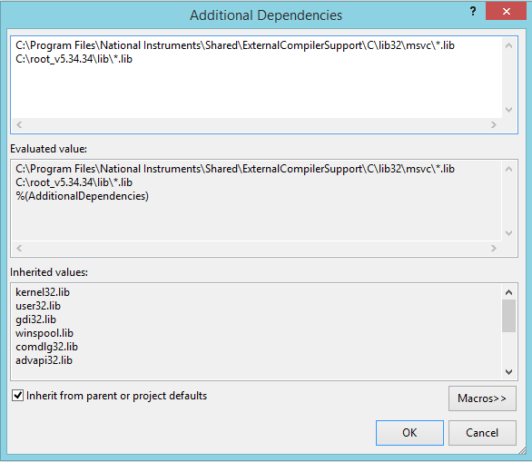

**References**

C:\Program Files\National Instruments\Shared\ExternalCompilerSupport\C\lib32\msvc\gpib-32.obj

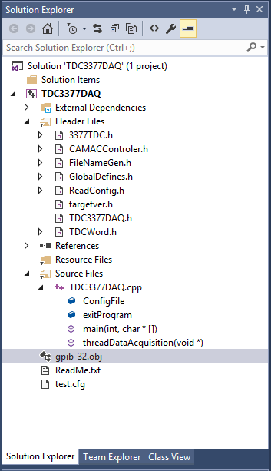

**GlobalDefines.h**

This header file contains two important variables, **READ_BUFFER_LENGTH** and **TREE_MAX_SIZE**.

The variable **READ_BUFFER_LENGTH** defines how much data is read during the 24 bit block read from the TDC, previously this was set to 100 which corresponds to 1 header word and 99 data words (or 48 double word times) which in some cases proved to be insufficient, hence it is set to 200.

The variable **TREE_MAX_SIZE** sets the maximum size in bytes for a tree file before a new file is created, keeping this low means many files but a low chance of losing data due to a power cut.

**TDC3377DAQ.cpp**

This file contains the **main()** function, however, DAQ is run in a separate thread called **threadDataAquisition()** which poles the TDC as often as there is data to read. The main thread waits for an input of x followed by the enter key to stop the acquisition and exit the program.

**CAMACController.h**

This contains the code as described in the LeCroy 8901A manual modified in such a way to work with the LeCroy 8901 unit. This code was given in C, as opposed to C++ hence where applicable the code has been modernised. For example in the case of a block read, the code now returns a vector of data words rather than requiring a pointer an array to store the data. Please consult the LeCroy 8901A manual for a full listing of the C code.